Investigating Striped Bass Biology in New York City’s East River Strait
By Devin M. Gorsen and Peter J. Park
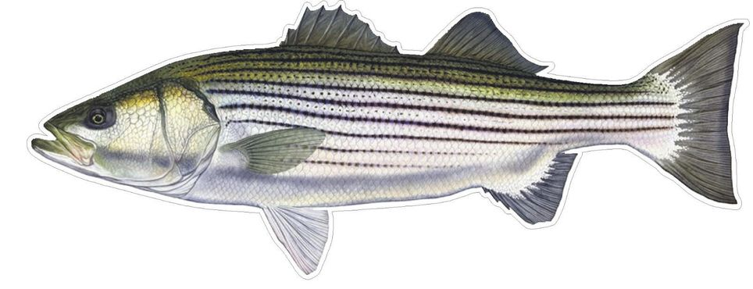
(Please do not share this document without consent from authors)

I. Introduction
The Hudson River Estuary, formed approximately 11,000 years ago as a result of retreating Wisconsin glaciers, joins freshwater from the Hudson River watershed with the marine waters of the Atlantic Ocean, and therefore consists of a mixture of freshwater and saltwater, known as brackish water. The East River is a part of this estuary and interfaces with four of the five boroughs of New York City (Fig. 1). Contrary to its name, the East River is not a true river but rather a tidal strait that connects the Upper NY Harbor to the Long Island Sound and the Harlem River, making Manhattan its own island, separate from Brooklyn, Queens, and the Bronx. The strait also separates Long Island and the Long Island boroughs from the rest of the state of New York.
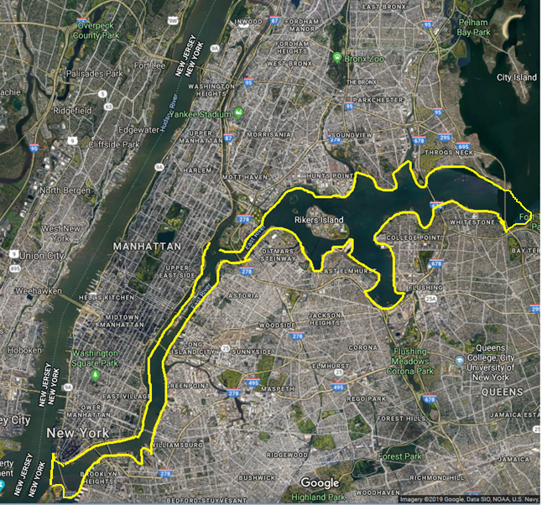
Fig. 1. The East River. Boundaries of the East River shown in yellow.

Estuaries provide vital habitat, breeding areas, and migration corridors for fishes and crustaceans. While some species live in the estuary year-round or spawn in shallow marshes, many estuarine fish species are either anadromous (migrate from saltwater to freshwater to spawn) or catadromous (migrate from freshwater to saltwater to spawn). This activity focuses on one of the most well-known and charismatic sportfish on the Atlantic Coast, the striped bass, which is an anadromous species.
In 2019, Atlantic striped bass data was compiled from multiple sites along the East River as part of a study called the East River Fish Project. Data contributors for this project included academic institutions, environmental education organizations, and recreational anglers, collectively known as the East River Ichthyological Alliance (ERIA) (see Park et al. 2020). This activity utilized this data and focuses on the relationship between size of striped bass in relation time of the year, geographic area, and type of capture method (Fig. 2). In New York state, anglers are permitted to keep their catch so long as the size of fish caught meets the requirement of current New York state fishing regulations. All undersized and oversized striped bass were released, and most bass that met the fishing regulation limit were also released; in the cases where bass was kept by anglers, they were always legal-sized “keeper-sized” fish.

A. 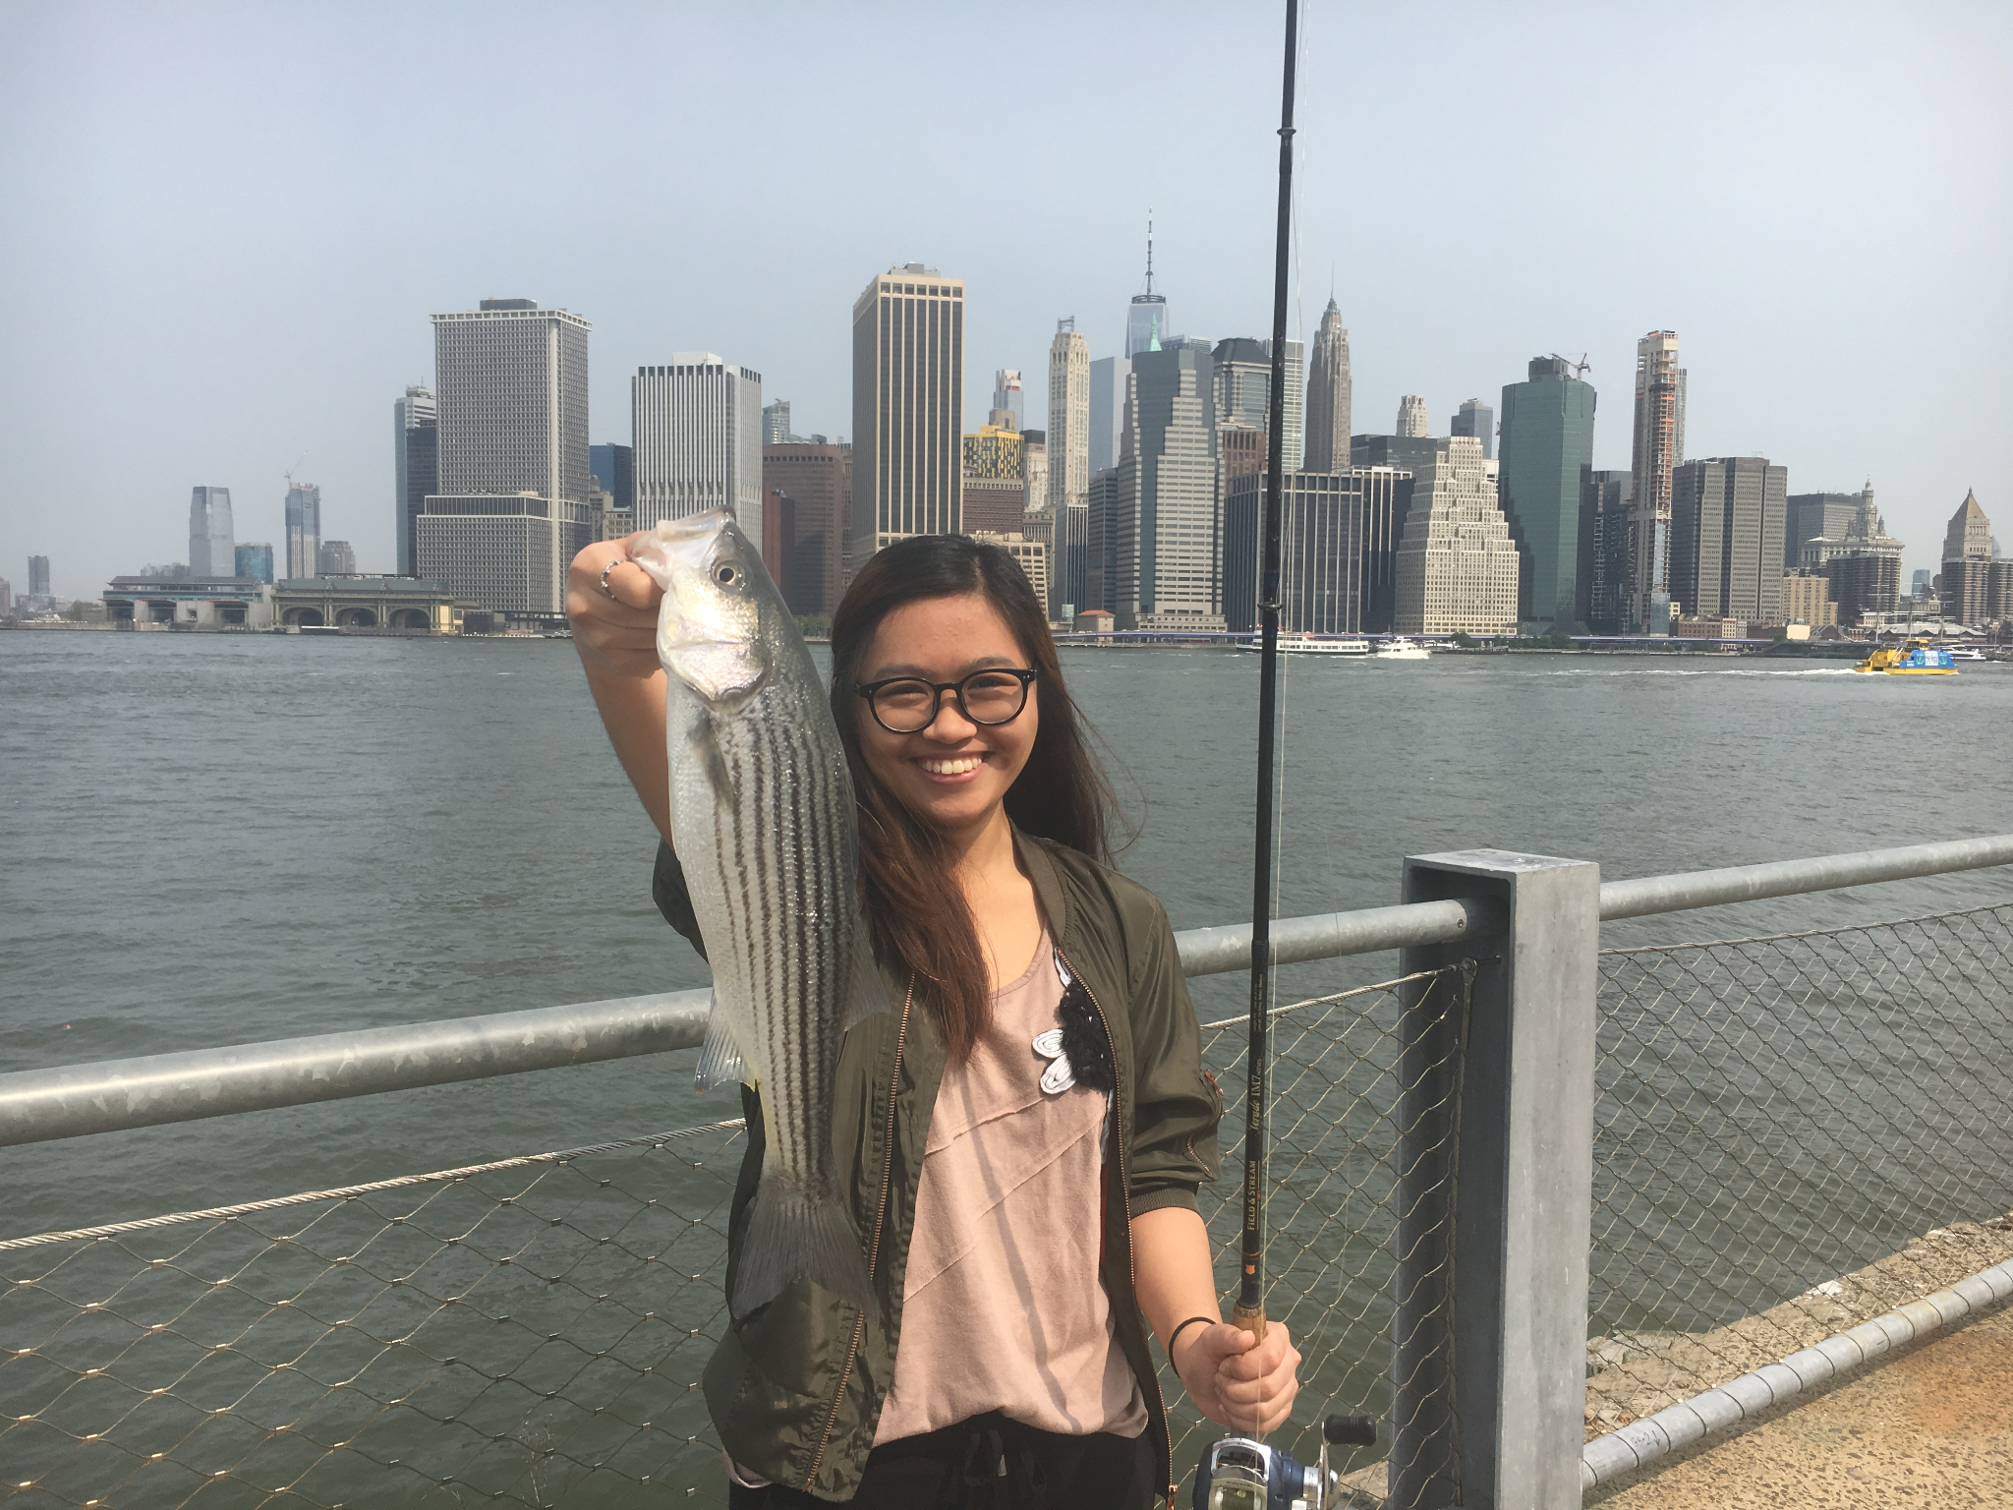 B. 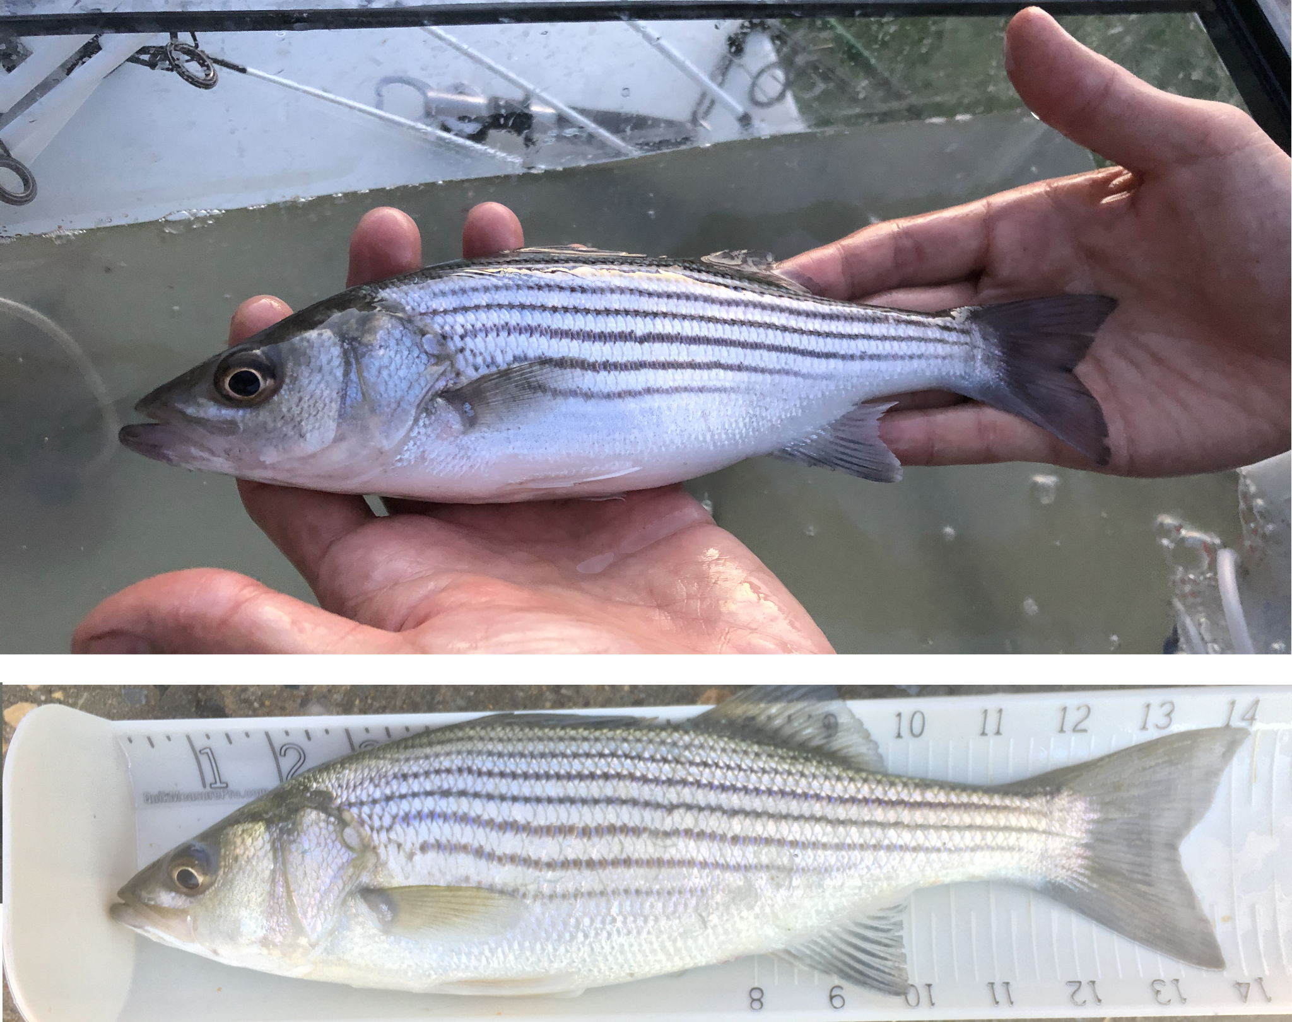
Figure 2A. East River Fishing clinic participant with striped bass at Brooklyn Bridge Park. This photo was also the Saltwater Fishing Winner of NYSDEC’s WomenHuntFishNY photo contest. (Photo by Peter J. Park) B. ERIA data collection process. Striped bass (Morone saxatilis) measurement method shown. (Photos by Peter J. Park)

II. Biology of Striped Bass (Morone saxatilis)
Life History of Striped Bass. The Atlantic striped bass is a ray-finned fish species with a natural geographic range along the Atlantic coast from Florida to Canada. They are anadromous with spawning migrations occurring in major estuaries such as the Hudson River and Chesapeake Bay during March. This activity focuses only on the Hudson River striped bass population, where spawning occurs generally from April to May.
Sexual maturity occurs sooner in males (2-3 years) than in females (5-6 years), with females typically outgrowing males. Males rarely achieve sizes of over 30 lbs. The largest known striped bass specimen was a 125lb female, caught in North Carolina in 1891 using a net. Table 1 shows a length-to-age chart for this species.
Every year, adult striped bass generally form migratory schools and begin in the estuary just after spawning. These schools then move north and east along the Atlantic coastline. Late in the summer, striped bass then turn back westward where they will eventually congregate and settle into sites in the ocean where they overwinter. Fig. 3 displays an angler-generated striped bass migration map for 2019.

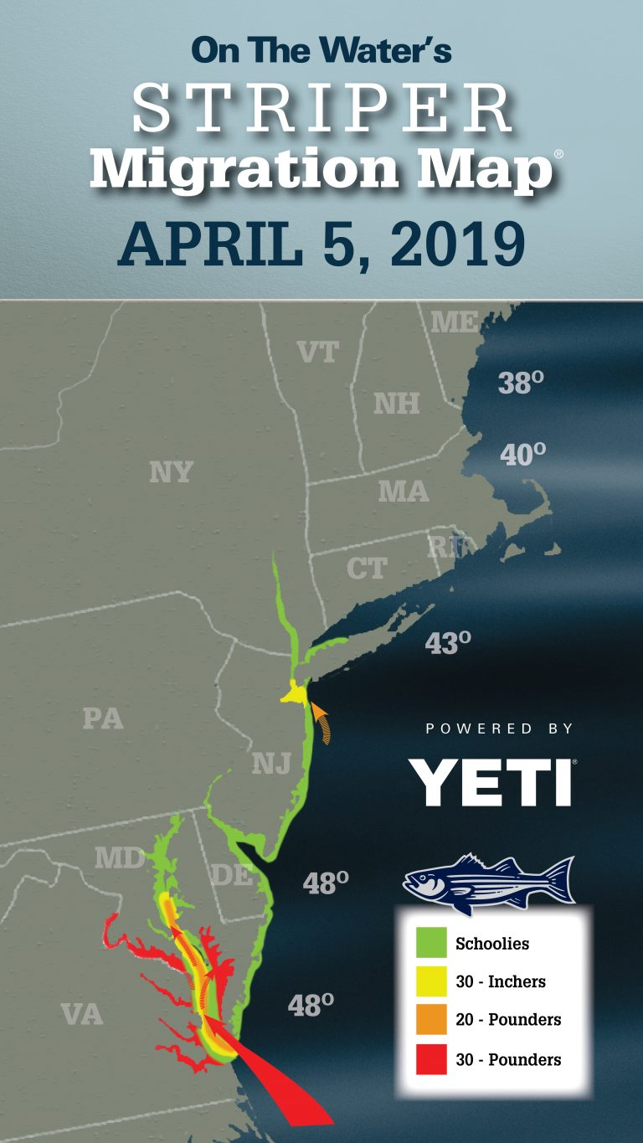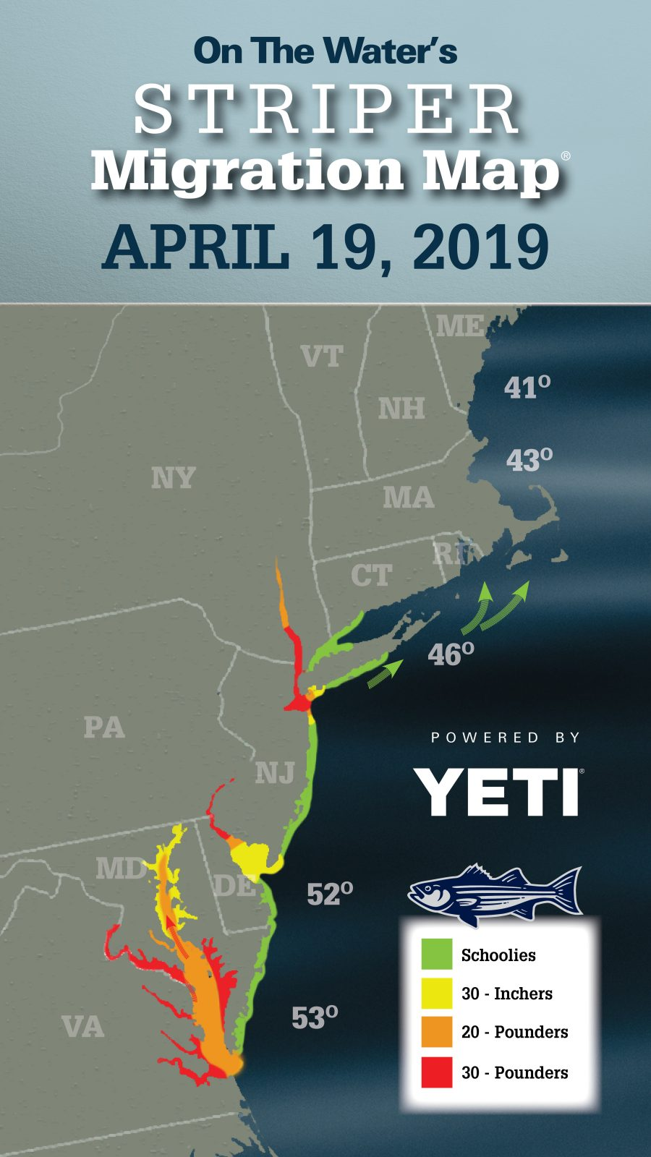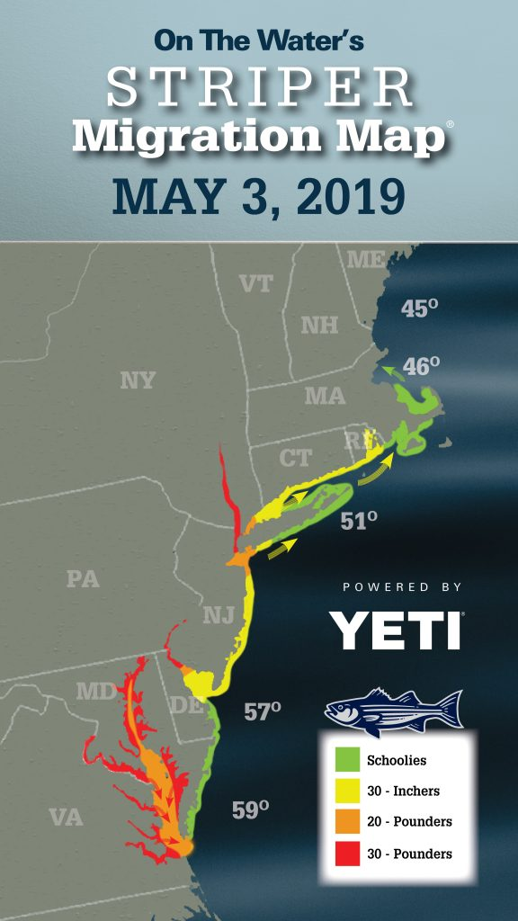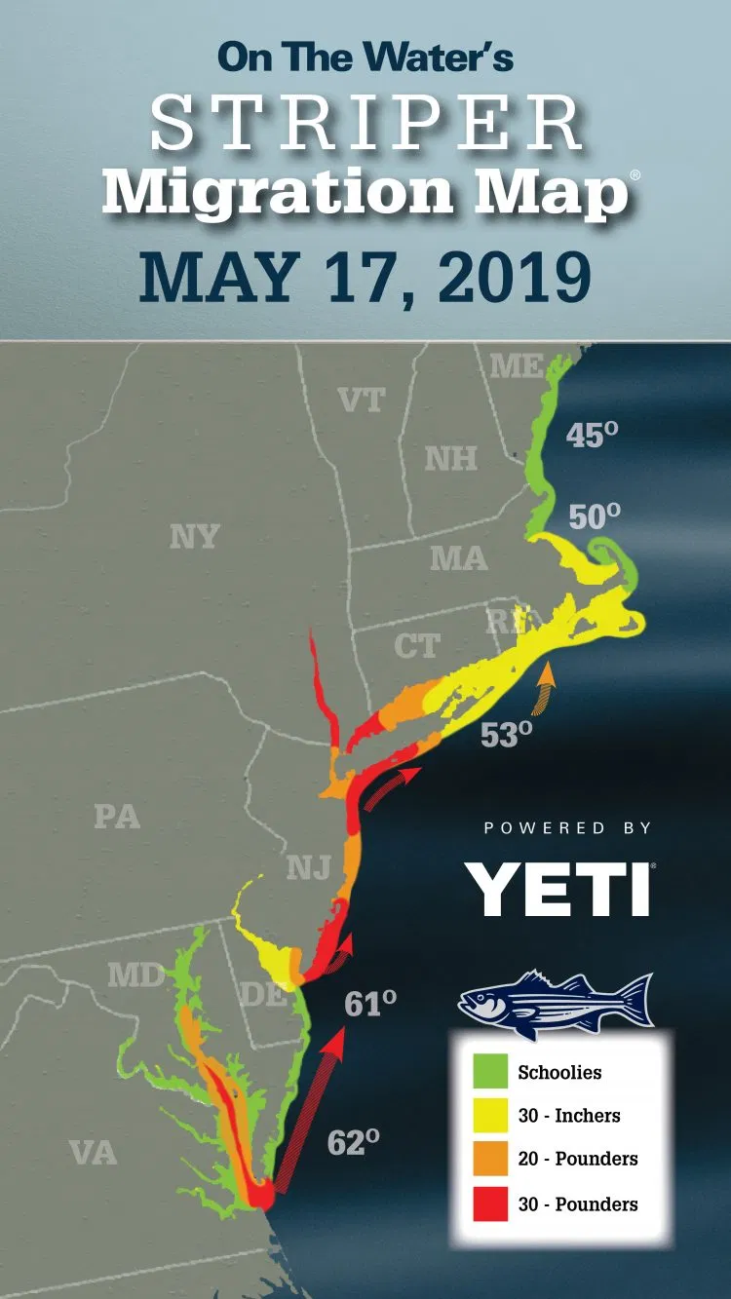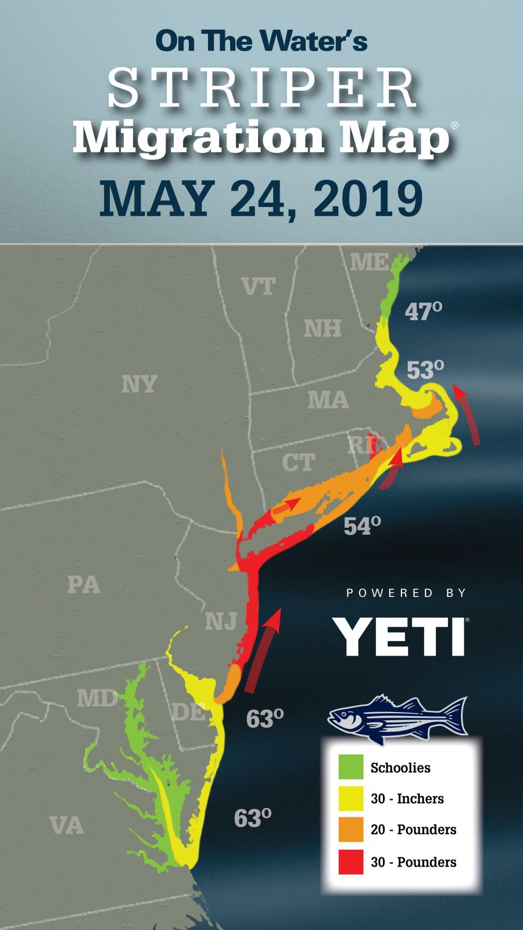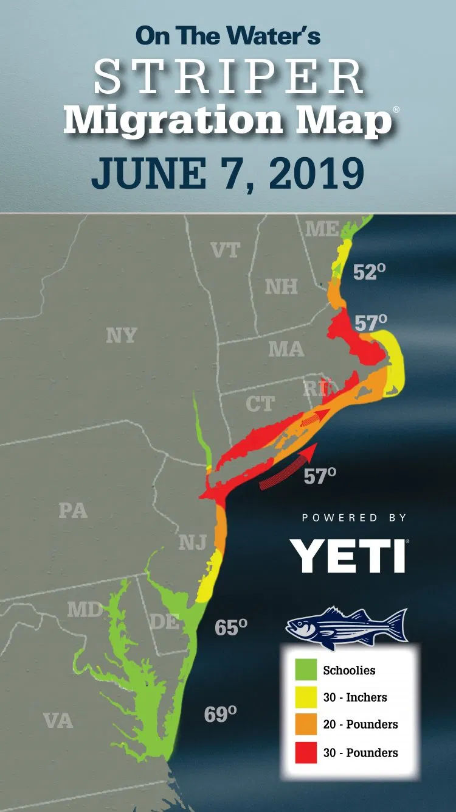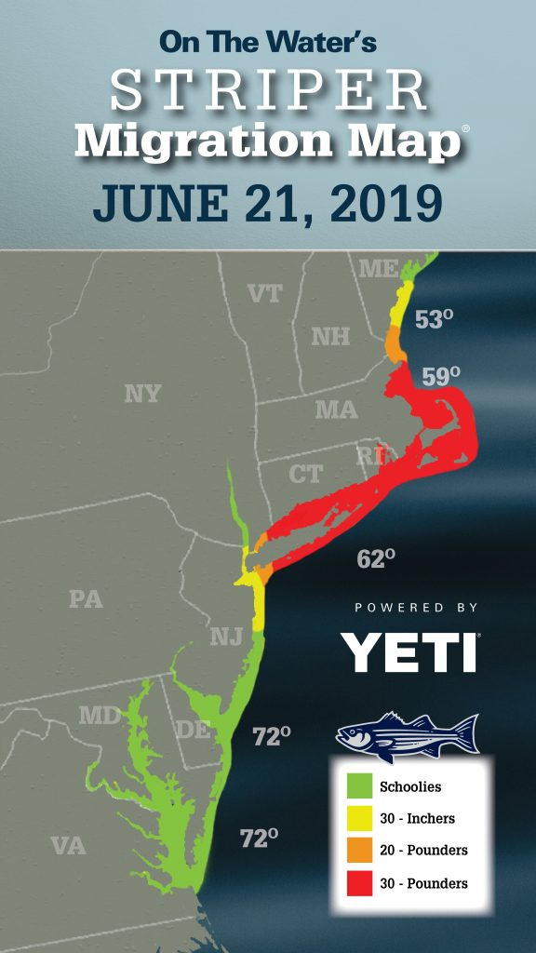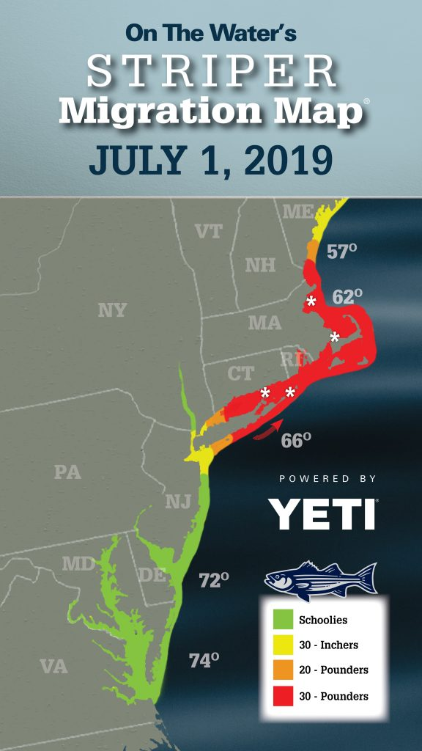
Figure 3. On The Water Striped Bass Migration Map. Maps, originally published in On The Water fishing magazine (https://www.onthewater.com/), were assembled using a wide range of sources such as fishing reports, tackle shop interviews, reader submitted reports on social media, and staff fishing reports. (Images courtesy of Kevin Blinkoff, On The Water magazine)
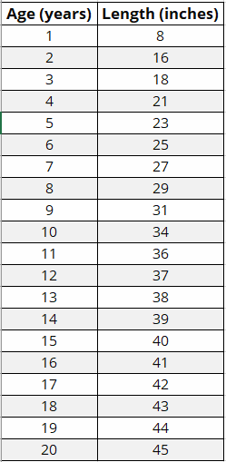
Table 1. Length-to-Age Chart for Striped Bass. (Image from CDEEP 2020)

Foraging Ecology of Striped Bass. The Atlantic striped bass is an opportunistic predator that feeds on plankton, molluscs, crustaceans, and other fish. Like many other ray-finned fish, striped bass are gape-limited predators in which consumption of prey is restricted by what can fit in their mouths. Smaller bass, such as young-of-the-year (YOY) feed mainly on plankton while larger bass eat other fish. Striped bass belong to ecological communities - different sizes of bass coincide with different trophic levels of the food chains or food webs to which they belong. Larger specimens of striped bass occupy upper trophic levels of a food webs, while smaller specimens occupy lower levels. As a general rule in ecology, as energy passes in any food web from one trophic level to the next level above, only about 10% of the available energy from that level is transferred (90% of energy is lost, Fig. 4). This explains, for example, why herbivores always outnumber carnivores in an ecological community.
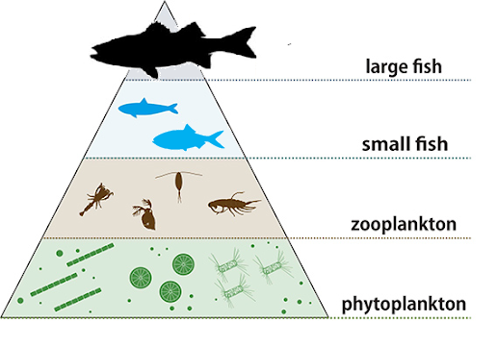
Figure 4. Energy pyramid of a generalized aquatic community in the East River. (Image adapted from JAMSTEC 2020)

Striped Bass Monitoring in the Hudson River Estuary. In the Hudson River Estuary, the status of the Atlantic striped bass fishery is monitored by the Department of Environmental Conservation (NYSDEC). This is accomplished using two methods:
Method 1 - Spawning Adult Stocks. Beginning in 1985, spawning stocks have been monitored from April through June in the Hudson River. Generally, the bass are released, but not before length, weight, and sex is recorded and samples of scales for aging are collected. For these surveys, a 500-foot seine net and electrofishing are employed.
Method 2 - Young-of-the-Year (YOY) Fish. Each year since 1979 from July to November, YOY Striped Bass have been monitored via surveys using a 200-foot seine net to determine annual abundance and sizes of fishes (Fig. 5).
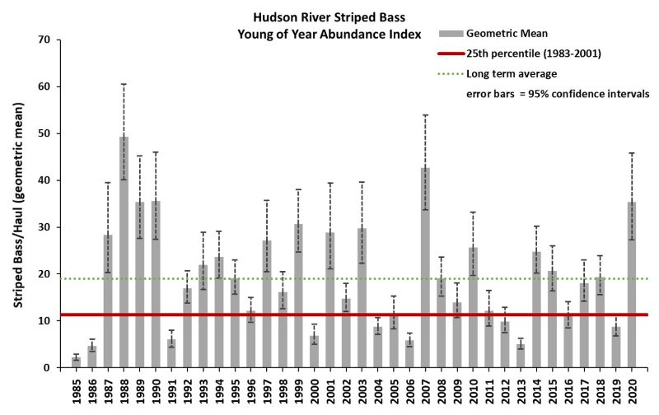
Figure 5. Annual catch of YOY Striped Bass since 1979. (Image from NYSDEC 2020a)

Community Science Surveying of Striped Bass. Although the NYSDEC annually monitors spawning and YOY Atlantic striped bass, a number of community science organizations also contribute valuable data on striped bass occurrence and sizes throughout various geographic regions along the Hudson River. Community science monitoring programs can take many forms, and in the East River, such programs include public seining programs, fishing clinics, or events that feature trapping. Read Park et al. (2020) to learn more about these programs and the fish collection methods that were used to acquire the 2019 East River Striped Bass data in this activity (Also found here: https://www.eaglehill.us/urna-pdfs-regular/urna-038-Park.pdf)

Recreational Angling for Striped Bass. Recreational fishing for striped bass is a popular pastime in the Hudson River Estuary and its surrounding marine waters. Historically, New York state fishing regulations for striped bass were always in the form of a maximum allowable daily quantity for harvesting and a minimum size limit. For example, between 2015-2019, recreational anglers fishing in marine New York waters were permitted to possess only one striped bass per day with a minimum total length limit of 28” for the harvested fish. However, beginning in 2020, the minimum size limit was replaced with a slot limit where the harvested fish size falls within a specific range thereby protecting smaller and larger fish outside the slot range. The slot limit aimed to protect the majority of spawning Hudson River female striped bass. Fig. 6 displays striped bass length distribution by sex and current recreational slot limit (outlined in light blue) of Hudson River striped bass. In 2020, this slot limit was 18-28” in the Hudson River itself (north of George Washington Bridge) and 28-35” in marine waters (south of George Washington Bridge).

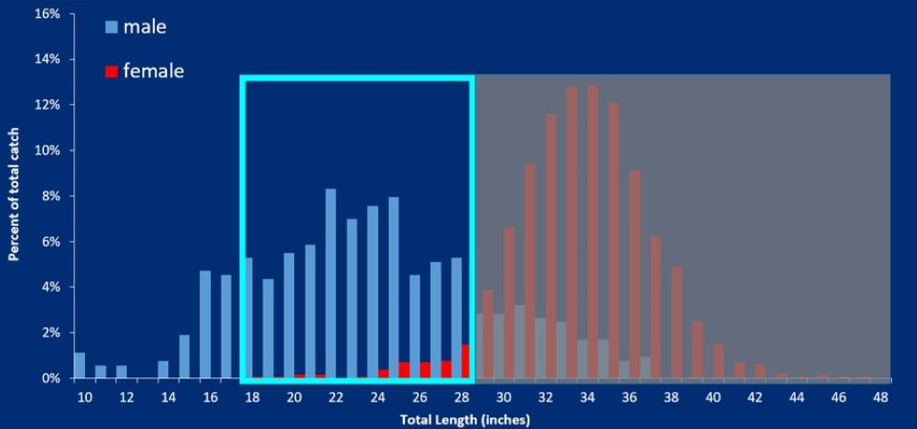
Figure 6. Striped bass length distribution and Hudson River recreational slot limit. Slot limit in the Hudson River shown in light blue outline. Shaded gray box indicates protected striped bass, most of which are females. (Image from NYSDEC 2020b)

III. Check Your Understanding
1. Based on your reading, answer the following questions that are related to the reproductive cycle of striped bass.
a) According to Table 1, what is the average size, measured in total length, of a 1 year-old Striped Bass?
b) Striped Bass are said to be anadromous. What does that mean?
c) At what size(s), measured in total length, do male and female Striped Bass generally become sexually mature?

2. Using the On The Water magazine’s migratory map (Fig. 3) above, describe the migratory patterns of Striped Bass born specifically in the Hudson River Estuary.

3. Recreational fishing for striped bass is quite popular in the East River. Starting in 2020, New York fishing regulations for striped bass became a slot limit (previously it was a minimum size limit). What is the current slot size and quantity limit for Striped Bass in New York?
Min:_______________ Max:_______________ Quantity of Fish Allowed Per Day: ____________

4. Read the following paper:
Conover, D.O. and Munch, S.B. 2002. Sustaining Fisheries Yields Over Evolutionary Time Scales. Science 297: 94-96.
Based on the findings presented in this paper, what makes a slot limit a more environmentally sustainable option than a minimum size limit?

IV. Research Questions. Below are some general observations about Hudson River Striped Bass that the authors of this activity have encountered through conversations with various groups of fish enthusiasts. Let’s see if we have enough data from the 2019 dataset to get some evidence-based answers!

Exercise 1: 2019 Distribution of Striped Bass by Age Class
General Observation: It is believed that Atlantic striped bass spawn in the main part of the Hudson River near Albany, which is far north of New York City’s East River. If that is the case, one might expect YOY bass to be rare in the East River because YOY are born in the Hudson River (and not the East River). Furthermore, striped bass generally are thought to not begin migrating outside the Hudson River until they reach sexual maturity. Large adult bass are also migratory but also occupy upper trophic levels of food chains.

Task: Based on your background reading in this activity, generate a hypothesis about the overall expected relative abundance of all the different age classes (at one-year intervals) of Striped Bass observed in the East River during 2019. Explain why you expect those particular relative frequencies.

Investigation:
1. Using 2019 data, how would you describe the distribution of striped bass catches in the East River?
2. Which Excel spreadsheet would you need to use to answer this question? [Suggestion for Instructor: Use Frequency Histogram Excel spreadsheet - Delete this comment before sharing this document with students.]
3. Open the provided datasheet (Filename: IMPORT DATA - ERIA_HHMI_DE - StripedBass2019.csv).
4. Using this Excel spreadsheet and Table 1 as a guide, copy the relevant data into the spreadsheet and create a frequency distribution (histogram) such that each “bin” is a 1-year age class. Thus, Bin 1 should be 1 year olds, Bin 2 should be 2 year olds, etc.
5. How do the results compare with your hypothesis?

-------------------------------------------------------------------------------------------------------------------------------

Exercise 2: Fate of the Striped Bass Fishery
General Observation: The newly implemented 2020 slot limit aims to protect large specimens of striped bass which are mostly sexually mature females.

Task: Based on your reading, generate a hypothesis about the expected relative abundance of the different age classes of Striped Bass observed in the East River in future years. Generally explain why you expect to observe those future relative frequencies.Please note that this exercise does NOT require an analysis using a spreadsheet; you only need to answer each of the two questions below in a few sentences.

Investigation:
1. Which Excel spreadsheet would you need to use to track change in future years? [Suggestion for Instructor: Use Frequency Histogram Excel spreadsheet - Delete this comment before sharing this document with students.]
2. Generally predict how the frequency distribution might change in future years.

-------------------------------------------------------------------------------------------------------------------------------

Exercise 3: Average Size of Striped Bass and Time of the Year (i.e., Month) Caught
General Observation: Some East River anglers believe that the biggest striped bass in the East River are caught only in the Fall.

Task: What is a relevant hypothesis based on the general observation above?

Investigation:
- Using 2019 data, what is the relationship of average size of striped bass and time of year caught?
- Which Excel spreadsheet would you need to use to answer this question? [Suggestion for Instructor: Use Linear Regression Excel spreadsheet - Delete this comment before sharing this document with students.]
- Using this Excel spreadsheet, which variables would you plot as the following:
X-Variable: ___________
Y-Variable: ___________
4. For this activity, we will also introduce you to Howard Hughes Medical Institute’s BioInteractive Data Explorer application: https://media.hhmi.org/biointeractive/tool/dataexplorer/v1/#/home.
  - Import the provided datasheet (Filename: IMPORT DATA - ERIA_HHMI_DE - StripedBass2019.csv)
  - Click on the “Visualize” option.
  - Choose the best plot that allows you to answer the main question for this activity.
5. How do the results compare to your hypothesis?

-------------------------------------------------------------------------------------------------------------------------------

Exercise 4: Capture Method and Average Size of Striped Bass Caught

General Observation: Some environmental educators believe that the average size of striped bass caught is influenced by the type of fish capture method employed. The types of capture methods in the 2019 dataset are angling during a fishing clinic, angling by recreational anglers during personal outings, seining during a public event, or trapping during a public event.

Task: What is a relevant hypothesis based on the general observation?

Investigation:
1. For this activity, we will use Howard Hughes Medical Institute’s BioInteractive Data Explorer application: https://media.hhmi.org/biointeractive/tool/dataexplorer/v1/#/home.
a. Import the provided datasheet (Filename: IMPORT DATA - ERIA_HHMI_DE - StripedBass2019.csv).
b. Click on the “Visualize” option.
c. Choose the best plot that allows you to answer the main question for this activity.
2. Which type of plot would you need to use to answer this question? [Suggestion for Instructor: Recommended plots are Scatter Plot or Bar Graph - Delete this comment before sharing this document with students] (Hint: Your data should be grouped into “Catch Method” using the “Grouping Variable” feature.)
-------------------------------------------------------------------------------------------------------------------------------

Exercise 5: Geographic Area and Average Size of Striped Bass Caught

General Observation: Some recreational anglers think that the average size of striped bass caught could differ across geographic regions.

Geographic Zones of Study in the East River: For convenience of this analysis, the East River can be conceptually divided into eleven different zones, labelled Z1-Z10, based on natural and/or anthropogenic landmarks. Note that Zone 4 is subdivided into two different zones (4a, 4b) because they occupy the same latitude (For reference, these are the same zones used in Park et al. 2020: https://www.eaglehill.us/urna-pdfs-regular/urna-038-Park.pdf).

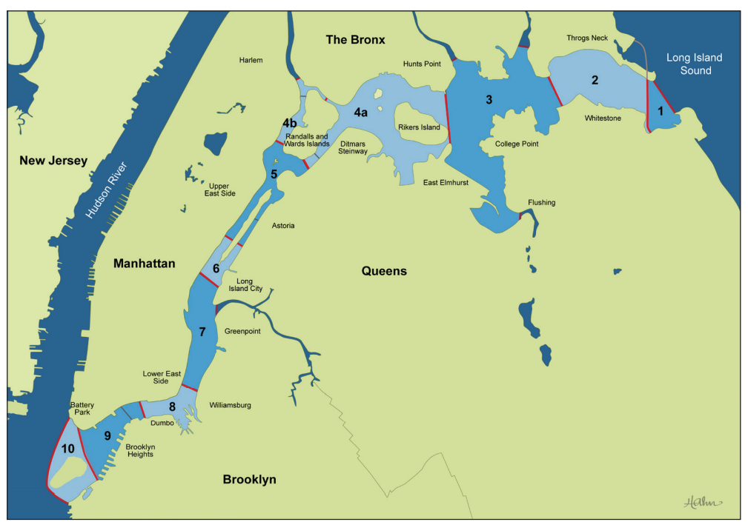
Figure 7. Geographic zones of the East River as found in Park et al. 2020.

Task: What is a relevant hypothesis based on the general observation above?

Investigation:
1. Using 2019 data, what is the relationship of geographic region of the East River and the distribution of average size of striped bass?
2. For this activity, we will use Howard Hughes Medical Institute’s BioInteractive Data Explorer application: https://media.hhmi.org/biointeractive/tool/dataexplorer/v1/#/home.
a. Import the provided datasheet (Filename: IMPORT DATA - ERIA_HHMI_DE - StripedBass2019.csv).
b. Click on the “Visualize” option.
c. Choose the best plot that allows you to answer the main question for this activity.
3. Which type of plot would you need to use to answer this question? [Suggestion for Instructor: Scatter Plot or Bar Graph - Delete this comment before sharing this document with students.] (Hint: Your data should be grouped into “Zone” using the “Grouping Variable” feature.)
-------------------------------------------------------------------------------------------------------------------------------

V. Notes for Instructor (Delete this section before sharing this document with students)
1. General Comment: This activity has focused on data visualization but not data analysis, except in the case of correlation or linear regression (i.e., exercises 4 and 5). Thus, some exercises can only be explained in general terms and would further require statistical tests to confirm differences.

2. Additional comments for Activity 1: Below are possible explanations for general differences among all the age classes.
- Statistics: It is difficult to tell if the histogram displays an unimodal distribution or a bimodal distribution.
- Ecology: Larger bass occupy higher trophic levels and thus are expected to be less abundant than smaller bass. Also, like most fishes, striped bass exhibit a Type III survivorship curve.
- Evolution and Life History: The goal of a slot limit is to protect large females. Female fish are generally favored over male fish for conservation efforts because larger females carry exponentially more eggs than smaller females.

3. General limitations to the 2019 data:
- Baseline data is needed, without which we cannot determine the following:
    - The relatively low number of larger bass in our 2019 dataset may or may not be typical of any other year in the East River.
    - The relatively low number of larger bass may or may not be due to migration out of the waterways adjacent to the Hudson River, which includes the East River.
    - Larger bass are also smarter bass, and thus, may be more challenging to catch unlike younger counterparts.
b. Recreational fishing limits were discussed. The relative impact of commercial fishing remains understudied.
c. We do not have genetic data to determine if all the fish in this 2019 study were from the Hudson River population.
d. The Hudson River population of striped bass generally spawn in the upstream portions of the Hudson River, and the offspring are generally thought to migrate out of the estuary in the ocean after they have reached sexual maturity (i.e., males older than 2 years old, females older than 4 years old). This may be one explanation for the low numbers in the smallest age class, YOY striped bass.
e. It is unknown if Striped Bass also spawn in the East River strait.

VI. Extensions
1. In 2020, this slot limit was 18-28” in the Hudson River itself (north of George Washington Bridge) and 28-35” in marine waters (south of George Washington Bridge). Why do you think the slot limit for Hudson River (“north of GWB”) is different for marine (“south of GWB”) Striped Bass?

2. Is it risky to eat Hudson River striped bass? Browse the following website: https://www.health.ny.gov/environmental/outdoors/fish/health_advisories/regional/hudson_river_and_tributaries.htm, interpret the plot in Fig. 8, and answer the following questions.
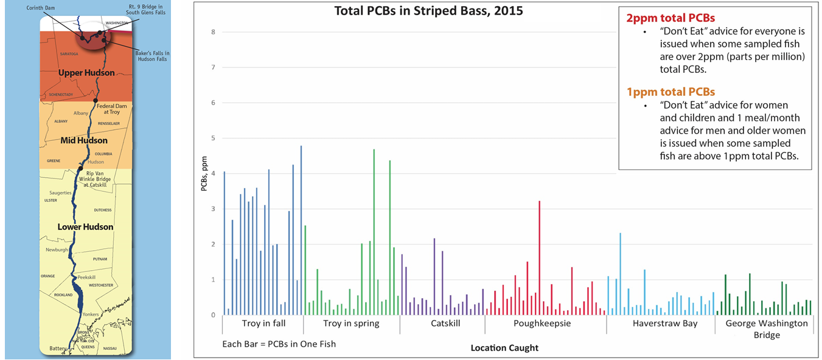
Figure 8. Total PCBs in Striped Bass in 2015
(Image courtesy of Audrey Van Genechten, New York State Department of Health).

a. What are consumption advisories for Striped Bass in the northern Hudson River, lower Hudson River, NYC marine waters, and Long Island waters?
b. Based on this data, how would you advise others about Hudson River striped bass consumption concerns?
c. What is your rationale for part (b)?

VII. Author Contributions. PJP and DMG - Introduction, Biology of Striped Bass, Notes for Instructor; DMG - Check Your Understanding, Exercises 1 and 2 of Research Questions; PJP - Exercises 3-5 of Research Questions, Extensions

VIII. Acknowledgements. We would like to thank the New York State Department of Environmental Conservation, especially Carol Hoffman and Caitlin A. Craig for providing a list of striped bass fishing regulations for New York State from 1976-present and Melissa K. Cohen and Steve D. Wong for constant guidance and feedback on all components of this activity. We are also grateful to the New York State Department of Health, especially Audrey Van Genechten for the provision of striped bass consumption advisory data. Lastly, we are indebted to New York Sea Grant, especially Antoinette O. Clemetson for encouragement and feedback on previous versions of all five exercises. Funding for the initiation of East River Ichthyological Database in 2019 was provided by the Marine and Coastal District License Plate, which is administered by the Marine and Coastal District of New York Conservation, Education and Research Board, and authorized through NYS Environmental Conservation Law Article 13, Title 5 Section 13-0503; this grant is a collaboration among Farmingdale State College, Nyack College, Brooklyn Bridge Park Conservancy, and Randall’s Island Park Alliance.

IX. References
HHMI BioInteractive Data Explorer. n.d. Available online at https://media.hhmi.org/biointeractive/tool/dataexplorer/v1/#/home. Accessed June 12, 2020.
Connecticut Department of Energy and Environmental Protection (CDEEP). 2020. How Old Is Your Fish? Available online at https://portal.ct.gov/DEEP/Fishing/General-Information/How-Old-Is-Your-Fish. Accessed June 12, 2020.
Conover, D.O. and S.B. Munch. 2002. Sustaining Fisheries Yields Over Evolutionary Time Scales. Science 297: 94-96.
Park, P.J., C.D. Girgenti, I.G. Del Bello, C.M. Tobitsch, D.M. Gorsen, K.C. Stanner, D. Van Horn, K.C. Wilding, L.F. Gonzalez, J.R. Wu, J.J. Adams, E.J. Reeve, M.E. Bender, C. Bowser, M.K. Turrin and T. Lake. 2020. New York City East River Fish Species Inventory and Emergence of a Unique Fish Community Science Network. Urban Naturalist. 38: 1-27.
New York State Department of Conservation (NYSDEC). 2020a. Striped Bass Length Distribution and Recreational Slot Limit in the Hudson River. Striped Bass in the Hudson River. Available online at https://www.dec.ny.gov/animals/108092.html. Accessed June 12, 2020.
NYSDEC. 2020b. Young of Year Striped Bass Abundance. Striped Bass in the Hudson River. Available online at https://www.dec.ny.gov/animals/108092.html. Accessed June 12, 2020.
Striper Migration Map. 2019. On The Water. Available online at https://www.onthewater.com/. Accessed June 12, 2020.
Japanese Agency for Marine-Earth Science and Technology (JAMSTEC). 2020. Mechanism of Resilience in Communities with Different Size Distributions -Underlying Mechanism of Biodiversity-Productivity Relationships Clarified. Available online at http://www.jamstec.go.jp/e/about/press_release/20161019/. Accessed June 12, 2020.

